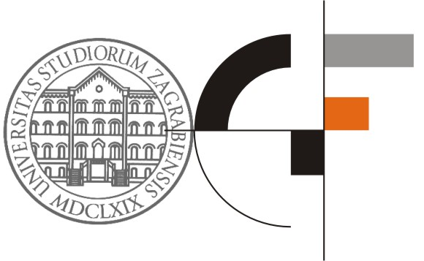

REGISTRATION FORM FOR THE
10th OTMC International Conference - Organization, Technology and Management in Construction
07. – 10. September 2011

- PARTICIPANT’S DETAILS
Please use UPPER CASE and send the completed form to OTMC2011@globtour.hr ,
fax: +385 1 481 22 77 or mail to: Globtour Event doo, Preradovićeva 14, 10 000 Zagreb

Family Name: ..................................................... First Name: ...................................................................

Title: ............................................... Area of Specialisation: ....................................................................

Department/Position: ...............................................................................................................................

Institution/Organisation: ...........................................................................................................................

Address (street, city): ................................................................................................................................

Postal code: ............................................... Country: ...............................................................................

Telephone: ....................................................... Fax: ..............................................................................

Mobile: ...........…........................................E-mail: ...................................................................................

- ACCOMPANYING PERSON DETAILS

- Family name: | First Name:

3. REGISTRATION FEES

CATEGORIES OF ATTENDANCE: | Before July 15th | After July 16th | ON SITE
Participant |  150,00 EUR |  170,00 EUR |  180,00 EUR
Postgraduate student |  40,00 EUR |  50,00 EUR |  70,00 EUR
Accompanying person |  40,00 EUR |  50,00 EUR |  70,00 EUR

4. SOCIAL EVENTS / MEALS

KINDLY CONFIRM YOUR PARTICIPATION IN:
Please indicate the number of social events and meals you are going to be present at:

Welcome drink, 07.09.2011, 20:00 h | Included in Conference fee(s) | No of persons: _____
Gala dinner, 09.09.2011, 20:00 h | Included in Conference fee(s) | No of persons: _____

Special dietary requirements: _________________________

5. ACCOMMODATION

Prices are per person per night, including breakfast, lunch and dinner. Kindly mark the preferred room type.

Hotel | Single room per day |  | Double room  per person per day |  | Triple room per person per day
Hotel Jakov *** | □ | EUR 71,00 | □ | EUR 56,00 | □ EUR 40,00
Hotel Ivan or Jure **** | □ | EUR 84,00 | □ | EUR 65,00

*prices don’t include city tax, EUR 1,00 per person per night

Date of arrival _____________________ Date of departure _____________________ No. of nights ______________

Person sharing my room / if in double room_______________________________Special request _____________________

6. CANCELLATION AND REFUND

Registration policy:
In case of cancellation processing fee of EUR 20,00 will be charged, per cancellation.
After August 15st there will be no refund.

Hotel and other policy:
No cancellation fee will be charged if the reservation is cancelled before 7th July 2011.
If there will be cancellation from 8th July to 22rd August – 50% of the total expenses will be charged.
If there will be cancellation from 23rd August to 4th September – 70% of total expenses will be charged.
If there will be cancellation from 5th September or NO SHOW – 100% of total expenses will be charged.

All refunds will be handled after the end of the Conference.

